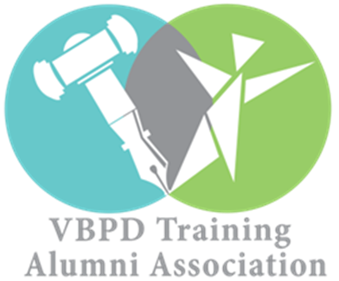

**SWA REGIONAL ALUMNI CHAPTER CALENDAR OF EVENTS**

**OCTOBER**

**DATE**: Monday- Friday, October 1st-5th

**REMOTE ADVOCACY EVENT: TEAL PUMPKIN EDUCATION**

**TIME:** N/A

**LOCATION:** Various locations in SWA

Throughout the Southwest Region Alumni will dessiminate the Teal Pumpkit Kit that will educate the population about non food treats for children with food allergies.

**Date:** Saturday, October 13, 2018

**CHAPTER MEETING**

**TIME: 2pm-4pm**

**LOCATION: Abingdon VA**

Virginia Highlands Community College

100 VHCC Drive

Room NEB 120

Abingdon, VA 24210

**NOVEMBER**

**Date:** Saturday, November 10, 2018

**CHAPTER MEETING: ROLE PLAY FOR DD DAY**

**TIME: 2pm-4pm**

**LOCATION: virtual, platform tba**

**DECEMBER**

**DATE:** Monday, December 3, 2018

**DIFFERENT ABILITIES DAY**

TYPE OF ACTIVITY: RVA Different Abilities Day Celebration at CMoR

TIME: 5:30-7:30

LOCATION: Children's Museum Chesterfield

6629 Lake Harbour Drive

Midlothian, VA 23112

Event is to bring awareness and celebrate persons with disabilities

**JANUARY**

**DATE:** Wednesday, January 14, 2019

**STATE ADVOCACY EVENT- DD ADVOCACY DAY**

TYPE OF ACTIVITY: Arc of Virginia Disabilities Day (DD)

TIME: 9:30-AM1:00PM

LOCATION: General Assembly Building

201 North 9th Street

Richmond, VA 23219

A Statewide Advocacy Event where Virginians galvanize to educate legislators & influence systems change

**FEBRUARY**

**Date:** Saturday, February 9, 2019

**CHAPTER MEETING: SPEAKER ON Applied Behavioral Analysis (ABA) THERAPY**

**TIME: 2pm-4pm**

**LOCATION: Roanoke VA**

**Meeting Place: TBD**

Speaker is an Autism expert and group will learn about this evidenced based, peer reviewed treatment for folks with autism. Issues raised and debated in the group will be summarized and used as a tool for members to speak to policymakers and others invested in the education system

**MARCH**

**DATE**: TBA

**RADFORD DISABILITIES AWARENESS WEEK**

Alumni will use this event for information gathering in an effort to identify pertinent, pressing issues in the college community. Follow-up after the event with a group letter college officials asking for attention to issues.

**TIME:** TBA

**LOCATION**: Radford University, Richmond, VA, 23231

**APRIL**

**DATE**: Saturday, April 13, 2019

**LOCAL ADVOCACY EVENT: Blue Ridge Independent Living Center (BRILC) INDEPENDENT LIVING EXPO**

TIME: To Be Determined

LOCATION: Blue Ridge Center for Independent Living

1502 Williamson Rd NE # B

Roanoke, VA 24012

Alumni will use this event for information gathering in an effort to identify pertinent, pressing issues in the community. Follow-up after the event with a group letter elected officials asking for attention to issues.

**MAY**

**DATE:** Saturday, May 5, 2019

**LOCAL ADVOCACY EVENT: ACCESSIBILITY AUDITS**

**TIME:** 2:00 PM – 4:00 PM

**LOCATIONS:** Throughout the region

Members throughout the region will go out in their town and audit the accessibility of businesses, sidewalks, transportation, ect. Information gathered will be presented to the localities via letters to town councils, or presentation to council members.